**Examen Bantrab - Andres Pineda**

* **GET - https://localhost:7095/Employee**

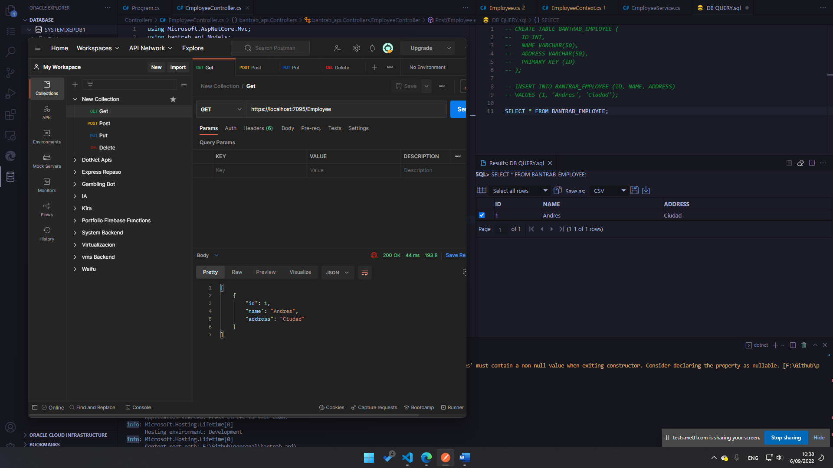

* POST (Create) **- https://localhost:7095/Employee**

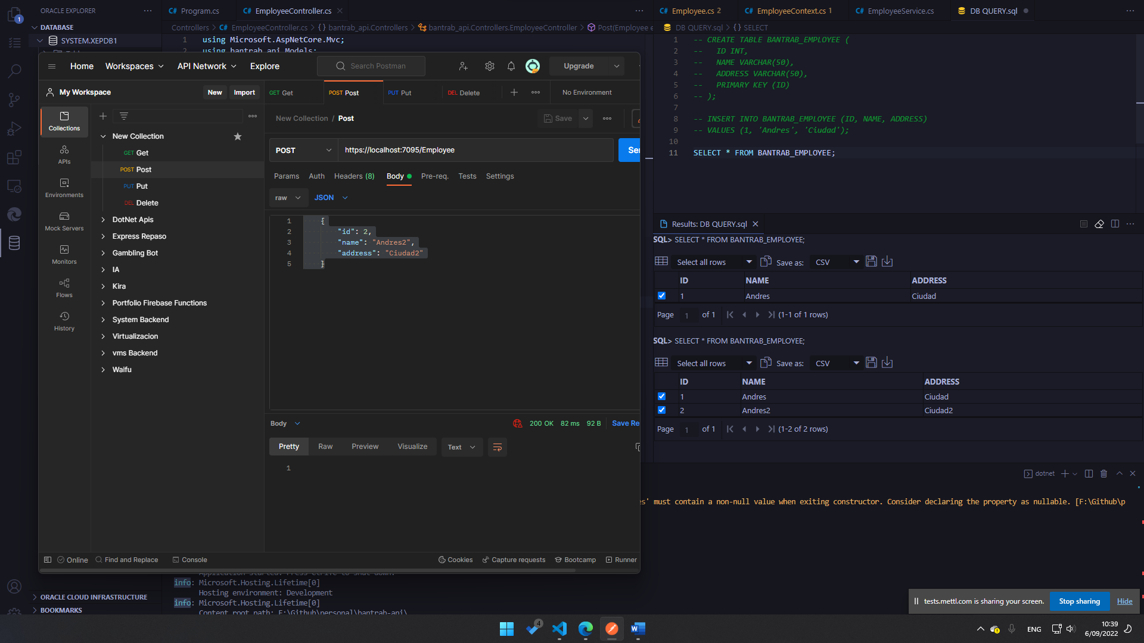

* Update (PUT) **- https://localhost:7095/Employee**

* DELETE  **- https://localhost:7095/Employee**

